- Prolog program for Tower of hanoi

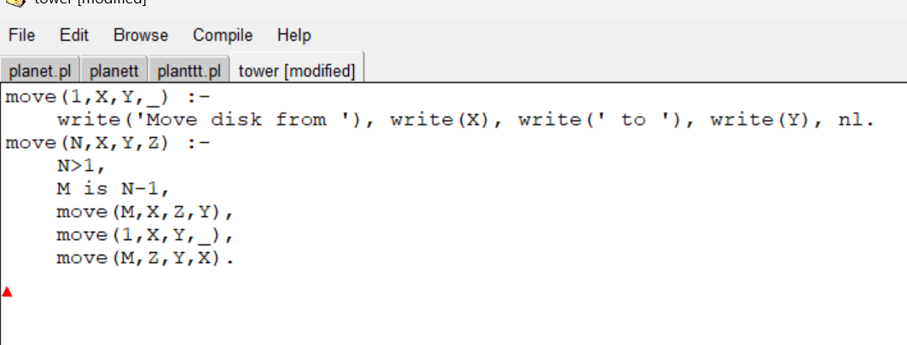

OUTPUT:

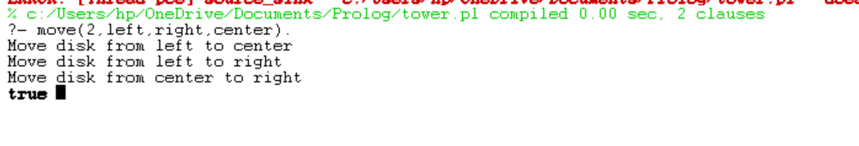

- Prolag program to fin the particular bird can fly or not

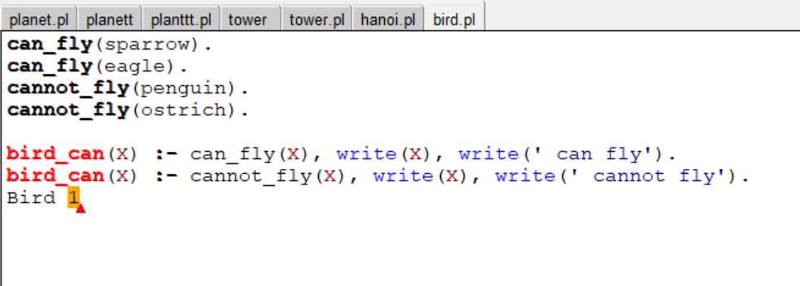

Output

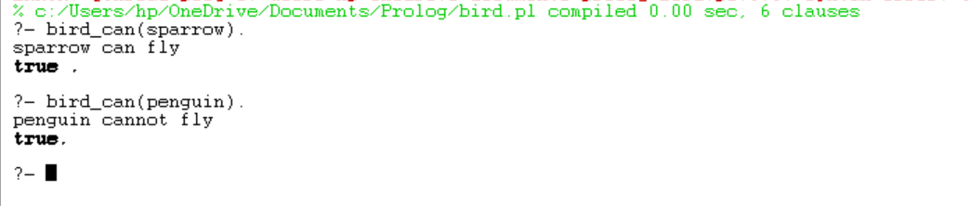

- Write the prolog program to implement family
tree
Pam, Liz, Ann and Pat are female, while Tom,
Bob and Jim are male persons.
Using this information, define the following
relations:
•Define the “mother” relation:
•Define the “father” relation:
•Define the “grandfather” relation:
•Define the “grandmother” relation:
•Define the “sister” relation
Define the “brother” relation

OUTPUT:

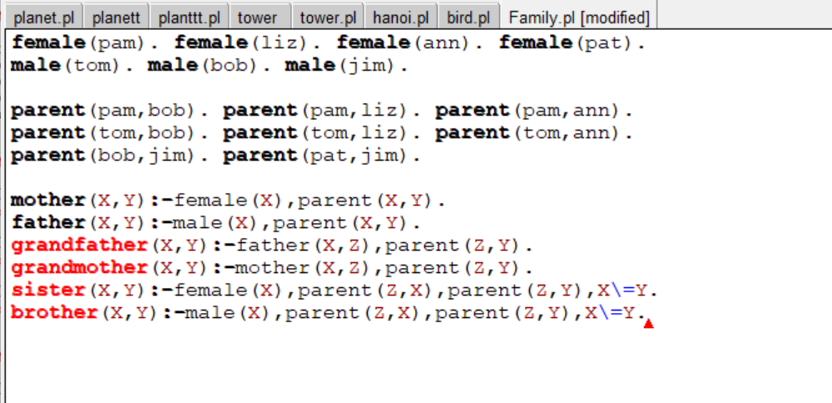

Output

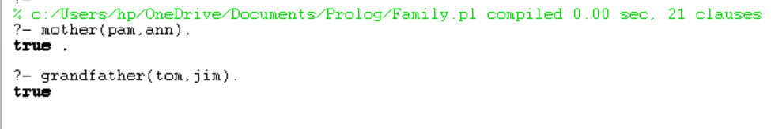

- Write a Prolog Program to suggest Dieting System based on Disease.

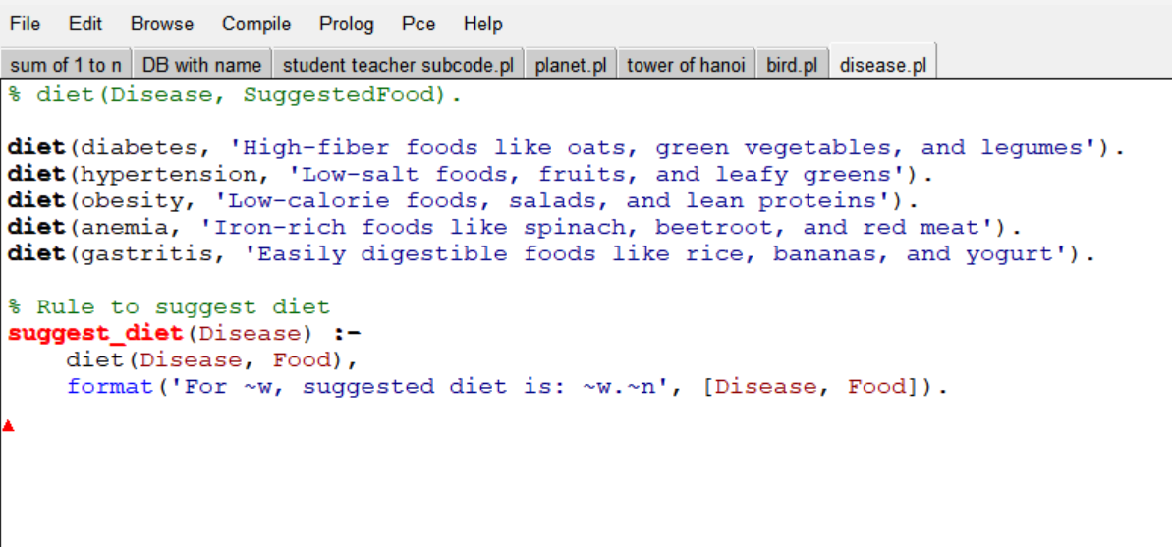

OUTPUT
